**Unix/Linux for Testers**

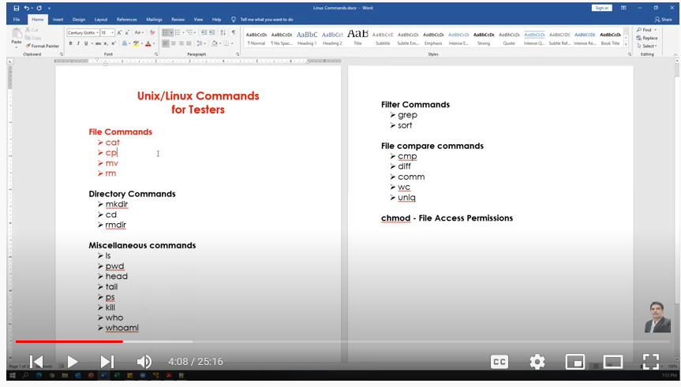

**Miscellaneous commands:**

(i) "Clear" is the command to clear the screen in Linux not *cls.*

**File Commands:**

**cat**

Creating the new file

Display content of the file

Concatenating more than one file

Appending data to the existing file

cp - Copy contents from a file to another file(source to destination)

mv

Renaming a file(changing name of the file)

Renaming a directory

Moves files from one directory to another directory

rm - Delete/remove a file or directory (only if directory is empty).

Note: (i) we can also create file using "touch" command. Difference between "cat" vs "touch".

(ii) File can be edited using "Vim" editor.

cat

cat >testing.txt # to create file

manual testing

automation testing

(ctrl+d) for exit

cat testing.txt # for display

cat yourdirecory/automation.txt # to display anything inside directory

cat testing.txt testing123.txt # for concatenate

cat >>testing.txt # for amend

cp

cp testing.txt testing_new.txt

# Copy contents from a file to another file(source to destination)

mv

mv testing.txt automation.txt # re-name a file

mv mydir yourdir # re-name a directory

mv automation.txt yourdir # moving a directory

rm

rm testing.txt # to delete a file

rm "directory name" # to delete a directory when it's empty

rm -r "directory name" # to delete a directory forcefully when some files in it

" -r" is used for recursive.

Note: we can also use "rmdir" command to delete a directory if it is empty

**Directory Commands**

mkdir - create directories and subdirectories.

mkdir testdir

create multiple directories at one time:

mkdir testdir1 testdir2 testdir3

create several subdirectories at one time:

mkdir -p world/countries/states

-------------------------------------------------------------------

cd - changing/closing directory

cd .. : go back to one level

cd /testdir1/testdir2/testdir3 → changing directory

pwd : it prints present directory

cd ~ Move to users home directory from anywhere.

------------------------------------------------------------------

rmdir - Remove the directory if it is empty (works only if directory empty)

rmdir world // error (because "world" directory is not empty)

** In this case we can use **"rm -r"** command

rm -r world

rmdir testdir1 testdir2 testdir3

**touch, pwd & ls Commands**

touch - to create a file

touch myfile.doc

touch /myhiddenfile.txt #to create a hidden file

---------------------------------------------------------------------------------------------------------------------------

ls : List Files

ls -l : (long list) shows file or directory, size, modified date and time, file or folder name and owner of file and its permission.

ls -a : view hidden files

touch .myfile.txt

ls -a

ls -l -a : detailed listing files along with hiddwn files

ls -F : will add the ‘/’ Character at the end each directory.

ls -r : display files and directories in reverse order.

ls -R : displays directories along with sub subdirectories

ls -lS : ("S" in upper case) displays file size in order, will display big in size first.

ls -l Documents : list files under directory Documents.

(I need to check this command in detail in future)

wild card characters

------------------------------

? Single character

* Multiple characters

[ ] Range of values

ls ?.*

Output: a.doc b.doc c.doc x.txt y.txt

ls ?.doc

Output: a.doc b.doc c.doc

ls ?.txt

Output: x.txt y.txt

ls a* Displays files which are starting with 'a'

Output: abc.doc a.doc

Range(Displays files starting with a to z)

--------------------------------------------------------

ls [a-z]*.*

Output:



ls [a-c]*.*

Output:



ls [a-z]*.txt

**head, tail, more & less Commands**

**Note:** Instead of "cat" command we have these following commands for display.

**head :** to display specified number of lines from top of the file.

--------

**head cities.txt**

* Display 10 lines from top of the file.

* 10 is the default value for head command

**head -n 15 cities.txt** (or) **head -15 cities.txt** # will show first 15 lines of the text

**head -n 5 cities.txt** # will show first 5 lines of the text

**tail** : to display specified number of lines from bottom of the file.

----------------

**tail cities.txt**

* Display last 10 lines from the file.

* 10 is the default value for tail command

**tail -n 15 cities.txt** (or) **tail -15 cities.txt** # will show last 15 lines of the text

**tail -n 5 cities.txt** # will show last 5 lines of the text

Display the lines from 10 to 15

**head -15 cities.txt | tail -6**

Display the lines from 20 to 30

**head -30 cities.txt | tail -11**

**ls - l** Display List of files and directories

**ls -l | head -5** Display Top 5 files and directories

**ls -l | tail -5** Display Top 5 files and directories

**more :** Display content page by page. **Forward directional**. Can't go to the previous page.

(Next page: press "space bar", Next line: press "Enter" button, Exit: press "q" button)

**more cities.txt**

**less** : Display content page by page in **both directions** means *next page or to previous page.*

(Next page: press "space bar", Next line: press "Enter" button, Exit: press "q" button)

(Previous Page: Press upper key "↑")

**less cities.txt**

-----------------------------------------------------------

**ls -l | more**

**ls -l | less**

**who, whoami, hostname, uptime, cal & date Commands**

who - Display how many users have connected to the Linux system

whoami - Displays the username of the current user.

hostname

----------

**hostname** : Print the host name of the system

**hostname -i** : print IP address of the computer

uptime

-----------

It is used to find out how long the system is active (running).

the current time,

the amount of time system is in running state

number of users currently logged into

the load time for the past 1, 5 and 15 minutes respectively.

---------------------------

cal : Display current month's calendar

cal 2021 : display calendar of specified year

cal 3 2021 : display specific month calendar in a year ( 3 rd month in 2021)

cal -3 : display previous, current and next month

cal -y : Display calendar of current year

cal -m10 : Display calendar of month n the current year

----------------

date

----------

date

date "+%Y" : Display year

date "+%m" : Display month(Number)

date "+%d" : Display date (Number)

date "+%d-%m-%Y" output: 05-12-2020

date "+%d/%m/%Y" output : 05/12/2020

date "+%d/%m/%y" Output: 05/12/20

date "+%a" display short weekday name (e.g., Mon)

date "+%A" display Full weekday name (e.g., Monday)

date "+%b" display short month name (e.g., Jan)

date "+%B" display Full month name (e.g., January)

date "+%H" Current hour in 24-format

date "+%I" Current hour in 12-format

date "+%M" Minutes

date "+%S" Seconds

date "+%H:%M:%S" Print Current time in HH:MM:SS Format [in 24-Hrs format]

date "+%I:%M:%S" Print Current time in HH:MM:SS Format [in 12-Hrs format]

date "+Today's Date & time is: %d-%m-%Y %I:%M:%S" [in 12-Hrs Format

Output: Today's Date & time is: 05-12-2020 11:46:55

date "+Today's Date & time is: %d-%m-%Y %I:%M:%S" [in 24-Hrs Format]

more formats of dates...

date --help

**wc, sort & uniq Commands**

wc --- to count total numbers of lines, word and characters

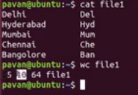

5 ---> Numbers of line

10 ---> Numbers of words

64 ---> Numbers of characters

"wc" command can be used for multiple files

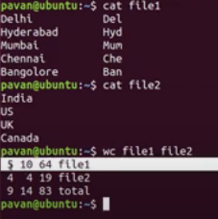

"wc" command can be used with "l", "w" and "c". "l" for no. of lines, "w" for no. of word and "c" for no. of characters.

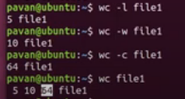

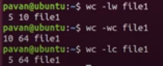

sort --- sort the data but only for Display Purpose. It doesn't change the original data.

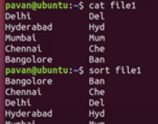

"Sort" command also sort the numbers in the same way.

After sorting the data we want to store the data in some new file. Please use "re-directional" arrow or "right arrow"



Sort the data from multiple files.

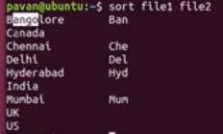

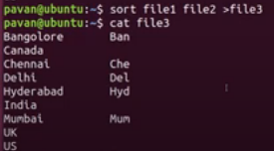

Sort the data in reverse order: *sort -r numbers.txt*

uniq command is used to remove duplicate values and stores only unique value.

to use "uniq" command data should be in sorted order.

uniq cities_new

uniq -d cities_new #d ---> for duplicate values

uniq -u cities_new #u ---> for unique values

uniq -c cities_new #c ---> how many times any word repeated

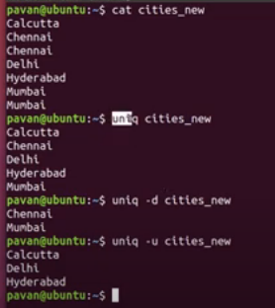

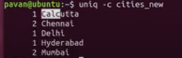

# cmp, diff & comm Commands